**A WEB-BASED RENTAL HOUSE LOCATOR WITH**

**FILTERED SEARCH AND MAPPING**

Undergraduate Capstone Project

Submitted to the Faculty of the

Department of Computer Studies of the

Cavite State University-CCAT Campus

Rosario, Cavite

In partial fulfilment

of the requirements for the degree of

Bachelor Science in Information Technology

**ALEX B. BANUG JR.**

**MARVIN D. NOEL**

May 2024

# **APPROVAL SHEET**

# **BIOGRAPHICAL DATA**

Alex B. Banug Jr. was born on October 20, 2001 in Pasig City. He is the second eldest of the six children of Mr. Alex L. Banug Sr. and Ms. Jenalyn B. Banug. He lives in Naic, Cavite.

In 2014, he finished his elementary at Petronilo L. Torres Memorial Elementary School in Sabang Naic, Cavite. He finished her junior high school in Ciudad Nuevo De Naic National High School at Sabang Naic, Cavite in 2018. His senior high school was taken in Amaya School of Home Industries at Sahud-Ulan, Tanza, Cavite and he finished in 2020 with honors.

He is now currently in college taking a Bachelor of Science in Computer Science at Cavite State University - CCAT Campus.

**BIOGRAPHICAL DATA**

Marvin D. Noel was born on January 26, 2002 in Las Piñas. He is the eldest of the two children of Mr. Felix Venida and Ms. Marlyn Venida and currently lives in Naic, Cavite.

In 2014, he finished his elementary at Masville Elementary School in Sucat Parañaque. He finished his junior high school in Ciudad Nuevo De Naic National High School at Sabang, Naic Cavite in 2018. His senior high school was taken in Amaya School of Home Industries at Halayhay, Sahud Ulan Tanza Cavite and he finished in 2020 with honors.

He is now currently in college taking Bachelor of Science in Information Technology at Cavite State University - CCAT Campus.

**ACKNOWLEDGMENT**

The authors would like to extend their warmest thanks and gratitude to the following persons who had been part of the conduct of this study:

Dr. Jose P. Rizal, capstone project adviser, for guiding and providing the researchers with the comments and suggestions which greatly contributed in the success of the study.

Dr. Pedro A. dela Cruz, technical critic, for giving them complete guidance and encouragement;

Ms. Jenery Y. Abad and Mr. Renato M. Bautista, DCS research coordinator, for their professional assessment and review of this capstone project;

Prof. Karlo Jose E. Nabablit, department chairperson, for had shared and for his professional assessment of this capstone project;

Dr. Aries M. Gelera, director of research and extension, for his..

Dr. Ariel G. Santos, director of instructions, for his…

Dr. Lauro B. Pascua, campus administrator, for his approval of this capstone project.

Their respondents, tester and evaluators of the system, for sharing their time and efforts in helping to accomplish the study.

Their classmates..

Their family…

Most importantly, to God Almighty, for all the strengths, guidance, and protection to the researchers to accomplish this research.

**THE AUTHORS**

# **ABSTRACT**

**ESTONILO, CHRISTOPHER G., GELERA, ARIES M., MUYOT, ALLEN JHON C., NABABLIT, KARLO JOSE E. Development of a Computerized Scheduling System for Computer Laboratory of Cavite State University-CCAT Campus.** Undergraduate Capstone Project. Bachelor of Science in Information Technology. Cavite State University-CCAT Campus, Rosario,Cavite. May 2024. Adviser: Dr. Jose P. Rizal. Technical Critic: Mr. Pedro A. dela Cruz.

Abstract states the time and place, objectives, methods, and overall results of evaluation of the system. Maximum of 200 words.

# **TABLE OF CONTENTS**

**APPROVAL SHEET ii**

**BIOGRAPHICAL DATA iii**

**ACKNOWLEDGMENT vi**

**ABSTRACT vii**

**TABLE OF CONTENTS viii**

**LIST OF TABLES x**

**LIST OF FIGURES xi**

**LIST OF APPENDIX TABLES xii**

**LIST OF APPENDIX FIGURES xiii**

**LIST OF APPENDICES xiv**

**INTRODUCTION 1**

Project Context 2

Objectives of the Study 2

Purpose and Description 3

Time and Place of the Study 3

Scope and Limitation of the Study 3

Conceptual Framework 3

Definition of Terms 4

**REVIEW OF RELATED LITERATURE 5**

Related Literature/Studies 5

System Technical Background 5

Synthesis 6

**METHODOLOGY** 7

Design of Software, Systems, Product and/or Processes 7

Requirement Analysis 8

Requirement Documentation 10

System Development 10

System Testing 10

System Evaluation 10

Implementation Plan 14

**RESULTS AND DISCUSSION** 16

System Design and Development 16

System Testing 16

System Evaluation 17

System Implementation 21

**SUMMARY, CONCLUSION AND RECOMMENDATIONS** 23

Summary 23

Conclusion 23

Recommendations 23

**REFERENCES** 24

**APPENDIX TABLE** 25

**APPENDIX FIGURES** 26

**APPENDICES** 27

# **LIST OF TABLES**

**Table Page**

Table 1. List of technical resources available in the organization 9

Table 2. Estimated cost of the system 9

Table 3. Software and data quality evaluation instrument 11

Table 4. Descriptive interpretation of the mean 14

Table 5. Implementation plan 14

Table 6. Functional testing 16

Table 7. Distribution of the evaluators 17

Table 8. Perception of the respondents on functional suitability 17

Table 9. Perception of the respondents on performance efficiency 17

Table 10. Perception of the respondents on compatibility of the system 18

Table 11. Perception of the respondents on interaction capability of the system 18

Table 12. Perception of the respondents on reliability of the system 19

Table 13. Perception of the respondents on security of the system 19

Table 14. Perception of the respondents on security of the system 20

Table 15. Perception of the respondents on flexibility of the system 20

Table 16. Perception of the respondents on the safety of the system 20

Table 17. Summary of the perception of the evaluators 21

Table 18. Summary of implementation results 22

# **LIST OF FIGURES**

**Figure Page**

Figure 1. Conceptual framework of the study 4

Figure 2. HIPO diagram of the system 7

Figure 3. Use-case diagram of the system 7

Figure 4. Graphical user interface of the system 8

Figure 5. Fishbone diagram of the system 9

Figure 6. Software methodology of the system using RAD 10

Figure 7. Login screen 16

# **LIST OF APPENDIX TABLES**

**Appendix Table Page**

Appendix Table 1. Title of Appendix Table 1 25

Appendix Table 2. Title of Appendix Table 2 25

# **LIST OF APPENDIX FIGURES**

**Appendix Figure Page**

Appendix Figure 1. Title of Appendix Figure 1 26

Appendix Figure 2. Title of Appendix Figure 2 26

# **LIST OF APPENDICES**

**Appendix Page**

Appendix A. Relevant Source Code 27

Appendix B. Evaluation Tool or Test Documents 27

Appendix C. Sample Input/Output/Reports 27

Appendix D. User’s Guide 27

Appendix E. Process/Data/Information Flow 27

Appendix F. Screen Layouts 27

Appendix G. Test Results 27

Appendix H. Sample Generated Outputs 27

Appendix I. Photo Documentation (during data gathering and evaluation) 27

Appendix J. Curriculum Vitae 27

Appendix K. Request for Title Approval Defense 27

Appendix L. Title Approval Sheet 27

Appendix M. Request for Adviser and Technical Critic 27

Appendix N. Program of Work (Gantt Chart) 28

Appendix O. Budgetary Requirements 28

Appendix P. Request for Proposal Defense 28

Appendix Q. Proposal Defense Evaluation 28

Appendix R. Outline Approval Sheet 28

Appendix S. Routing Slip before ERB 28

Appendix T. Certificate of Approval (Ethics Review Board) 28

Appendix U. Request for Final Defense 28

Appendix V. Final Defense Evaluation 28

Appendix W. Certificate of Completion 28

Appendix X. Routing Slip 28

Appendix Y. Certificate from the English Critic 28

**A WEB-BASED RENTAL HOUSE LOCATOR WITH**

**FILTERED SEARCH AND MAPPING**

**ALEX B. BANUG JR.**

**MARVIN D. NOEL**

An undergraduate capstone project manuscript submitted to the faculty of the Department of Information Technology, Cavite State University-CCAT Campus, Rosario, Cavite in partial fulfillment for the degree of Bachelor of Science in Information Technology. Contribution No. _______________. Prepared under the supervision of Dr. Jose P. Rizal and Mr. Pedro A. dela Cruz.

# **INTRODUCTION**

Providing a safe and secure shelter is a basic human need. It protects us from the elements, provides privacy, and acts as the foundation for both physical and mental health. It is what humanity intended for home. Having a roof over our heads allows us to sleep well, store our stuff, and create a relaxing and healthy environment. Many people cannot afford to be homeowners or to purchase land on which to build a permanent home owing to a lack of funds, or their salary is only enough to feed their family every day, so they prefer to rent a home.

Rental property owners, often known as landlords, provide a home for renters who are with a group, family, or individual who are looking for a place to stay for months or on a contract basis. Once the property is bought, the rental owners will collect the rental payment as per their agreement with the renter, which will continue until the next due date. There are numerous rental housings throughout the city that people may be interested in based on their individual circumstances and personal needs, which is why they are important to the economy because of their convenience and play a critical role. As crucial as it may appear, many rental housings are inaccessible or difficult to locate due to their location and position in the neighborhood. Despite its convenience, it lacks a commercial potential to attract a tenant, which may impede their company; nevertheless, such a problem can be solved by utilizing technology and the power of the Internet.

## The researcher’s solution is to create a web application entitled “A web-based rental house locator with filtered search and mapping” where both renter and property owner can benefit. The renter can locate a nearby rental house base on his/her preferences and which to think more affordable. The property owner can showcase and display his/her rental house and attract a potential tenant by the use of the website and with the locator embedded, it can trace the location of its position to the renter who might use the said web application.

## **Project Context**

Finding suitable rental property in the ever-changing world of urban living has become a major challenge for both individuals and families. Rent that is commonly heard of, is a source of revenue gained by the ownership, control, or possession of valuable assets in the face of little to no competition (Christophers, 2019). Rent-generating assets do not always have to be land but they could be financial assets or intellectual property, for example. However, land is undoubtedly the most rentable asset. According to James Chen (2022), homes bought by an investor and leased to tenants under some other forms of rental agreement are referred to as residential rental property. These homes serve as a vital part of the housing market, giving people and families a place to live while also giving investors a way to make rental income and perhaps even experience long-term capital growth.

The challenges faced by someone especially, newcomers in a city, such as their unfamiliarity with the area and the time-consuming nature of finding a suitable rental house without proper context, result in a state of confusion and frustration. Spending too much money on a place to live or stay is out of the question because it can be difficult if you run out of money, especially if you're a low-income earner or rely solely on parental allowance. Buying pricey locations and you'll never make money (Smith, 2023). While rent control rules and regulations vary by location, most rent control consists of price rises caps within the period of a tenancy, and sometimes beyond the duration of a tenant, as well as eviction restrictions (Diamond, 2018). The appearance of a rental house is far more crucial for the renter in terms of their preferences and health concerns. Rental properties are more likely to have mold than other types of homes. This is a problem because excessive mold development is known to be harmful to human health (Bently et al, 2023). This is why most renters are cautious to rent residences in a given location or condition. Finding an affordable rental house can be challenging for someone who is saving money or who is on a tight budget for several months (Ward, 2017). Students and other boarders are also the one’s affected in an instance looking for an affordable rental housing. According to Lamudi.com (2021), many students have trouble obtaining suitable and inexpensive student accommodation due to high demand for spaces near schools or higher prices for freshly developed ones. These issues are constantly destroying the peace of mind of any tenants who aspires to find and rent a residence.

As the world's population continues to concentrate in cities, there is a greater need for efficient and user-friendly solutions for finding rental properties. With the widespread use of technology and the increasing reliance on web applications, there is an opportunity to employ technology to simplify the house-hunting process. The impact of information and communication technologies (ICT) on how people search for rental property has been significant. The incorporation of ICT technologies into the real estate sector has not only streamlined but also made the process more accessible and efficient in this digital era.

The project entitled A Web-Based Rental House Locator with Filtered Search and Mapping is one of the products of the ICT technologies in progress that will develop an innovative Web-based application that will simplify the process of discovering rental properties while increasing the user search experience. The program will contain complex features such as filtered search functionality and interactive mapping to allow users to tailor their search to their specific interests and needs. The incorporation of new application aims to improve not only the efficiency of finding rental properties, but also the user experience.

## **Objectives of the Study**

## The objective of the study is to provide an innovative web application that can simplify the finding of rental houses/apartments when the renters need and to showcase the rental housing of the property owner. Specifically, this study aims to:

## 1. develop a project title “A Web-Based Rental House Locator with Filtered Search and Mapping” using Visual Studio as a software material with JavaScript as programming language, and MySQL for database included and the following features:

## a. User Registration and Login - It allows the user to create an account and login to start personalizing their experience in finding a rental house using the mobile application.

## b. Filtered Search - Allow the users to use filters like location, price range, number of bedrooms, amenities, and more.

## c. Mapping Interface - Using a map interface to display rental property listings in a certain area.

## d. Property Description - It consists of a detailed property description of a rental house/ apartment such as images, rental terms, the contact information, etc. that is chosen by the user.

## e. Booking – Allows users to save the rental house that they might settle in based on users own preferences and interest.

## 2. evaluate the apartment management system using the modified International Organization for Standardization and International Electro-technical Commission (ISO-IEC) 25010; and

3. deploy the website to a web hosting site to make it available on the web. monitor the website performance continuously to ensure seamless functioning and user experience.

## **Purpose and Description**

The purpose of creating a mobile application titled "A Web-Based Rental House Locator with Filtered Search and Mapping" is to help consumers find rental houses or apartments more successfully. The project's purpose is to provide a user-friendly interface that allows users to search for rental properties based on certain criteria and visualize them on a map, improving the entire rental property search experience. Those who will benefit include the following:

Renters - Individuals or families looking for rental houses are the key benefits. The program simplifies the process of discovering suitable rental houses, saving users time and effort.

Property Owner - Increased visibility for rental listings benefits both property owners and real estate agents. The software could attract potential tenants while also making the property advertising process more effective.

Developer - The app's developers benefit from building a functional and potentially popular application, which may lead to financial benefits, recognition, and future development opportunities.

**Time and Place of the Study**

The study will be conducted at Tejeros Convention from December 2023 to May 2024.

## **Scope and Limitation of the Study**

This study focused on developing the web-based rental house locator that may help the renters easily locate their preferred rental houses around the area in Tejeros Convention. The study was conducted during December 2023 to May 2024.

Furthermore, this study will not extend to the factors that may affect the property owners’ reputation by the feedback coming from the renters against the issue of rental houses owned by themselves. Also, the web application’s effectiveness only relies on an internet connection for real-time data retrieval and communication.

**Conceptual Framework**

This section uses the Input-Process-Output (IPO) model that will provide the general structure and guide for the direction of the study as shown in Figure 1.

*Sample:*

Evaluation

**Figure 1. Conceptual framework of the study**

The Input Process Output (IPO) diagram of A Web-Based Rental House Locator with Filtered Search and Mapping is shown in Figure 1. In order to conceptualize the idea of this study, the researcher makes use of the related studies for further knowledge about the study itself. The process is composed of planning, design, development, testing, evaluation, and deployment of the system.

## **Definition of Terms**

**Blockchain** - a decentralized, distributed and public digital ledger that is used to record transactions across many computers so that the record cannot be altered retroactively without the alteration of all subsequent blocks and the consensus of the network.

**E-commerce** - buying and selling of goods and services, or the transmitting of funds or data, over an electronic network, primarily the internet. These business transactions occur either as business-to-business (B2B), business-to-consumer (B2C), consumer-to-consumer or consumer-to-business.

**User-Friendly** - describes something such as a machine or system as user-friendly, you mean that it is well designed and easy to use.

# **REVIEW OF RELATED LITERATURE**

## **Related Literature/Studies**

According to Bashari & Hashim (2019), In Nigeria, it shown that the people live there has over 7 out of every 10 people live below minimum poverty level and 9 of every 10 are in the low-income group which indicates that these people are hardly or cannot provide permanent houses for themselves so that they need the intervention of government to push the public low-cost housing. Given that the situation of the families is in a crucial state, they are in need of shelter that will cost them only a minimum penny considering they are low-income earner, they can at least spend the rest for foods and everyday necessities. As public low-cost housing has been heard and funded by the government or in partnership with the government to provide affordable housing for low-income earners, the results have shown that there is a need to consider user preferences when building public low-cost housing in order to achieve maximum satisfaction.

In Addition, PD&R (2023) states that the low-income renters are struggling with the high cost of housing by which only favors people with wealthy lifestyle and because of its widening gap, the insufficient affordable housing cannot be apply for them however, the enterprise community partners gathered affordable advocates, practitioners and government officials to discuss about the said issue and as a result, the speakers discussed for the housing affordability crisis which will enlighten the low-income earners and since some of its factor is for education purposes and job opportunities, a nearby and close housing with affordable cost is a better option in underscoring the importance of investing in affordable rental housing. Strategies for wealth creation and community ownership can help low-income renters and their neighbors share social and economic returns.

## **System Technical Background**

The web application is composed of various tools and software that will help the researchers to build the system. Throughout the development process, we follow a disciplined workflow that includes design, frontend, and backend development. The researchers proceeded to use Visual Code Studio, a source code editor that is commonly used for programming and development tasks. The next one is HTML or Hypertext Markup Language, used for creating the structure of web pages. It provides a set of markup tags that define the various elements of a web page, such as headings, paragraphs, images, links, forms, and more. CSS or Cascading Style Sheets, used for styling HTML elements to control their appearance on web pages. Additionally, JavaScript is a programming language used in web development to provide interactivity and responsive design to online sites. Lastly, PHP, a server-side scripting language used in web development to generate interactive website contents and communicate with databases. Along with MySQL, a popular open-source relational database management system that is frequently used with PHP for storing and retrieving data for online applications. Utilizing these will contribute to establishing a dynamic platform that guarantees seamless functionality and improves user satisfaction.

## **Synthesis**

By the help of gathered resources throughout the related articles, the Researchers follow and use it as a guideline for developing the web application, The preferences of the renters vary according to their personal circumstances or the salary basis for choosing a rental housing and since some of it only favors with someone wealthy, people demand for a low-cost housing that is affordable. As for the property owner, they lack of commercial of their houses in order to attract tenant to live for the spaces.

# **METHODOLOGY**

This chapter includes the design of software. Systems. Products, or processes, system development, system testing and evaluation, data analysis and implementation plans of the study.

## **Design of Software, Systems, Product and/or Processes**

The Researches used a flowchart to illustrate every modules of the system that will start at Figure 2.

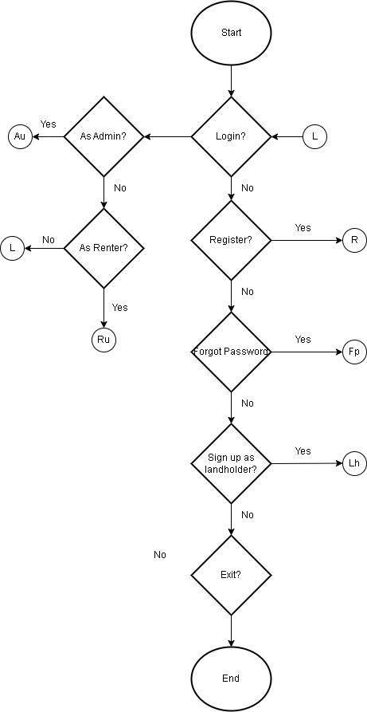

**Figure 2. Flow chart for User Login**

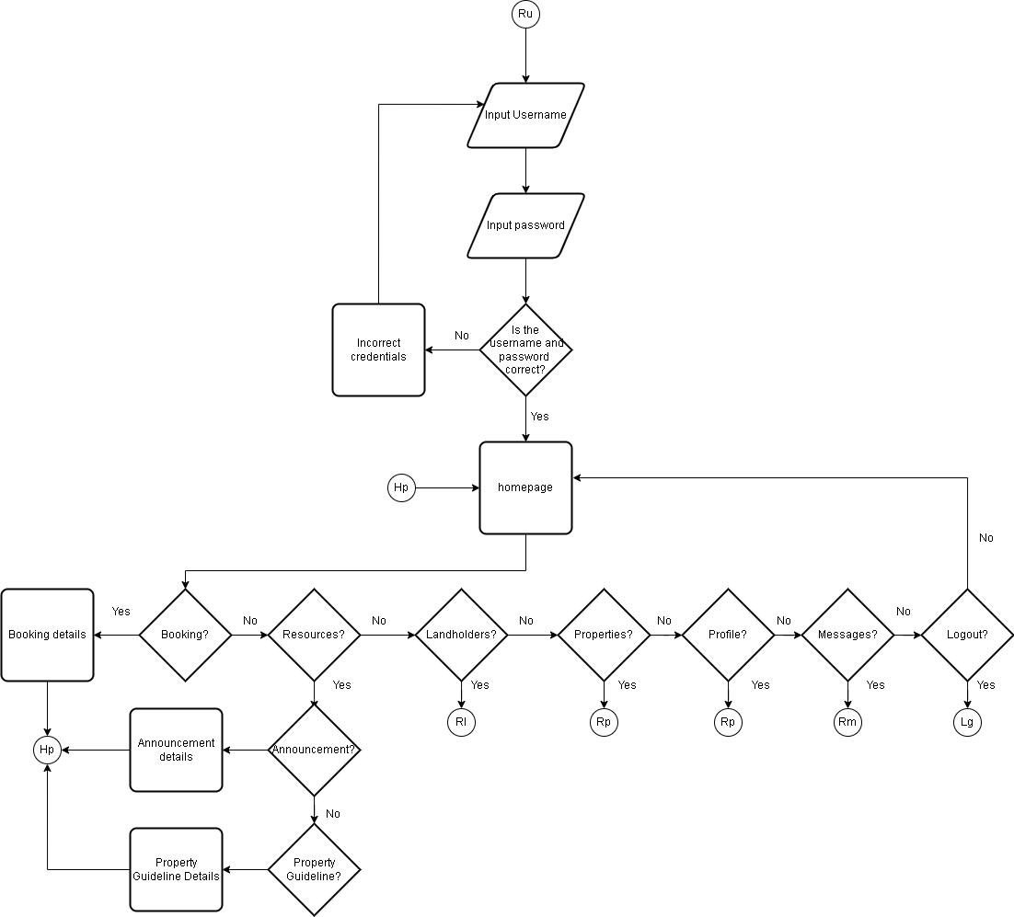

**Figure 3. Flowchart Illustration of Users Homepage, Booking and Resources**

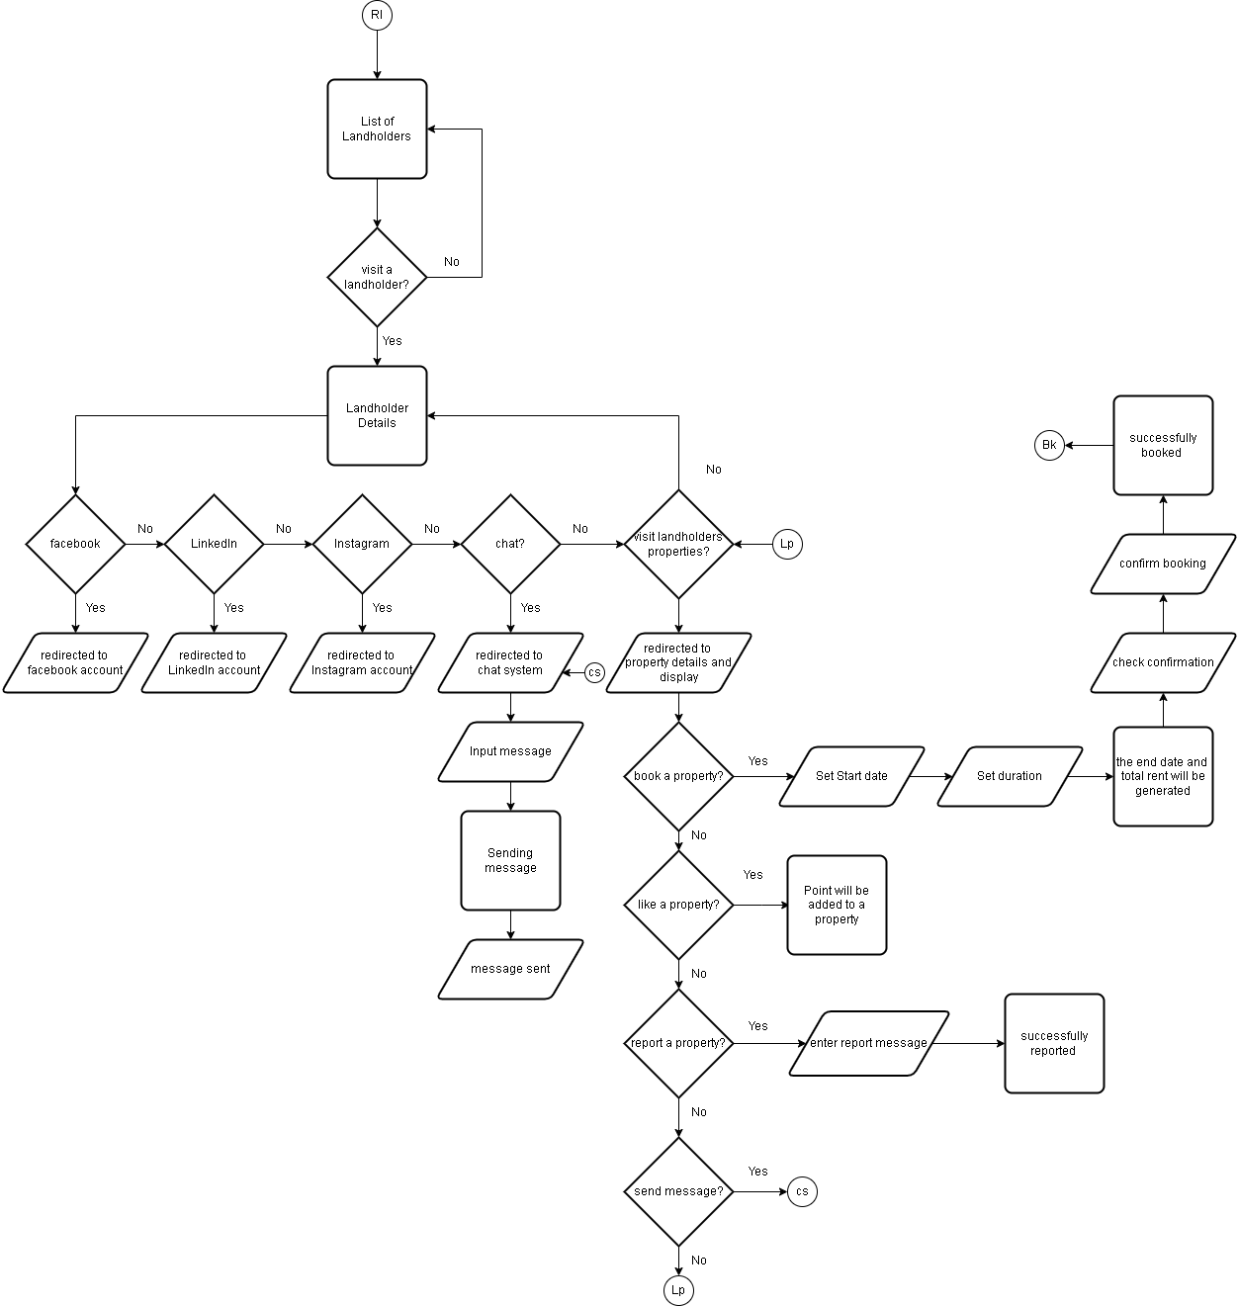

**Figure 4. Flowchart Illustration in Landholder Page under renters Interface**

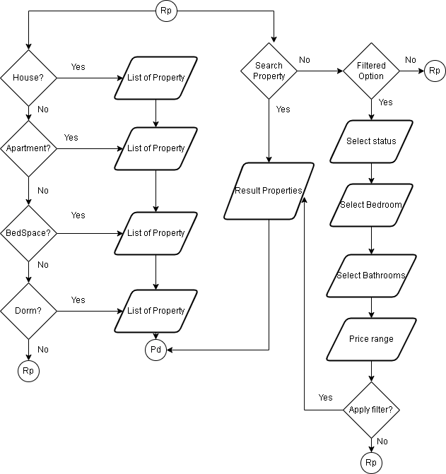

**Figure 5. Flowchart Illustration about the properties under renters interface**

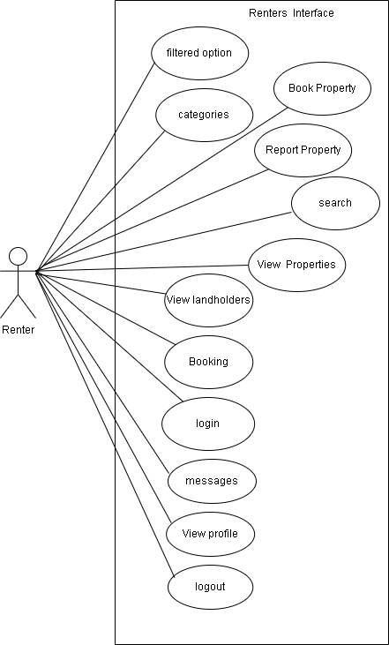

**Figure 3. Use-case diagram – Renters Interface**

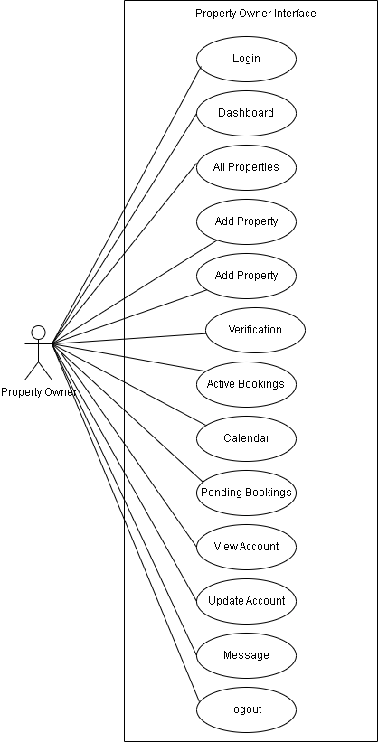

**Figure 4. Use Case Diagram – Property Owner Interface**

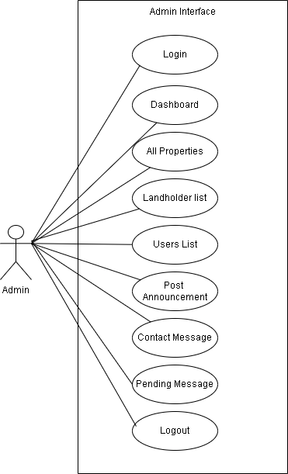

**Figure 5. Use Case Diagram – Admin Interface**

Figure 4 shows the graphical user interface design of the system.

**Figure 4. Graphical user interface of the system**

### **Requirement Analysis**

The researcher should identify the details and functions of the current system of the organization that they will study. It shall discuss and answer the following questions: who – the people who are involved; what – the business activity, where –the environment in which the work involved; when – the timing, and how – how the current procedures are performed. Diagrams to clearly describe the system requirements should be provided in this phase.

*Example:*

Figure 5 presents a fishbone diagram that shows the operational feasibility of the system.

**Figure 5. Fishbone diagram of the system**

Table 1 presents the list of technical resources available in the organization that can be used to run the system to be developed.

**Table 1. List of technical resources available in the organization**

|  |  |
| --- | --- |
| **LIST OF RESOURCES AVAILABLE** | **STATUS** |
| 3 units of Personal Computer | Working |
| 1 Laptop | Working |
| 3-in-1 Printer | Working |
| Handheld Scanner | Working |
| Digital Camera | Working |

Table 2 presents the estimated cost of the system development.

**Table 2. Estimated cost of the system**

|  |  |
| --- | --- |
| **LIST OF EQUIPMENT** | **COST** |
| PC | PhP 0,000.00 |
| Smart Phone | PhP 0,000.00 |
| Scanner | PhP 0,000.00 |
| **TOTAL COST** | PhP 0,000.00 |

### **Requirement Documentation**

This phase discusses what the software will do. It includes the modules of the proposed system/solution with the description.

## **System Development**

The research should include the software development model that will be used in the study. The researcher needs to discuss each of the phases in the model to be used.

*Sample:*

Rapid application development (RAD) was the software methodology used in the development of the system as shown in Figure 6.

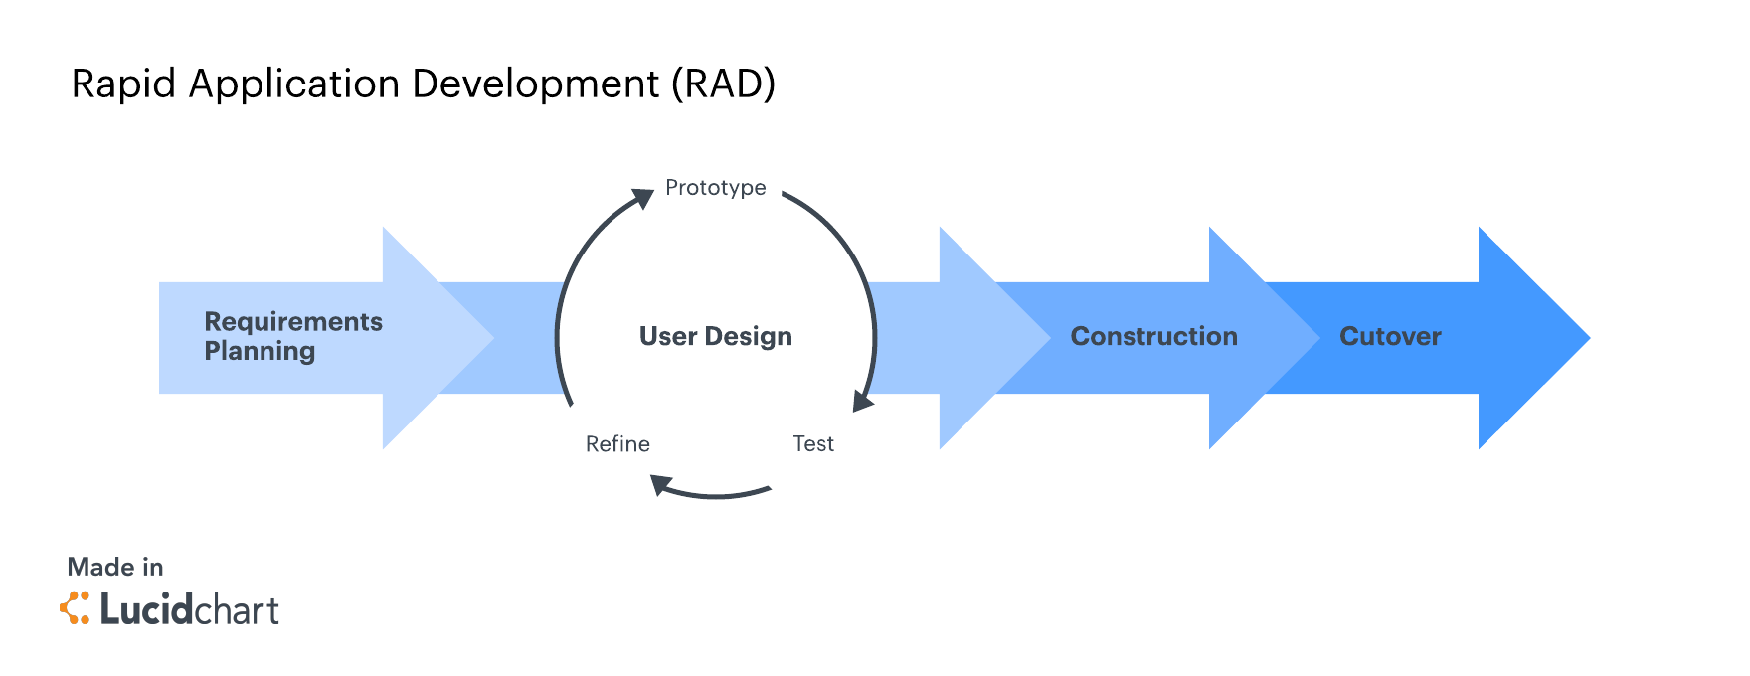**Figure 6. Software methodology of the system using RAD**

**Discuss each phase of the RAD – requirement planning, user design (prototype, test, redefine), construction, and cutover. (For Computer Science Thesis, discuss the dataset collection, model building, model validation, model deployment to the application or system)**

## **System Testing**

During the testing phase, the researcher should cite the testing procedures conducted in the study.

## **System Evaluation**

The system was evaluated based on modified ISO/IEC 25010 Software and Data Quality Evaluation Instrument. This is in terms of functional suitability, performance efficiency, compatibility, interaction capability, reliability, security, maintainability, flexibility, and safety as shown and n Table 3.

**Table 3. Software and data quality evaluation instrument**

|  |  |  |  |  |  |  |  |  |  |
| --- | --- | --- | --- | --- | --- | --- | --- | --- | --- |
| **INDICATOR** | **5** | | **4** | | **3** | | **2** | | **1** |
| **A. Functional Suitability** | | | | | | | | | |
| 1. ***Functional completeness*** - degree to which the set of functions covers all the specified tasks and intended users' objectives. |  |  | |  | |  | |  | |
| 1. ***Functional correctness*** - degree to which a product or system provides accurate results when used by intended users. |  |  | |  | |  | |  | |
| 1. ***Functional appropriateness*** - degree to which the functions facilitate the accomplishment of specified tasks and objectives. |  |  | |  | |  | |  | |
| **B. Performance Efficiency** | | | | | | | | | |
| 1. ***Time behaviour*** - degree to which the response time and throughput rates of a product or system, when performing its functions, meet requirements. |  |  | |  | |  | |  | |
| 1. ***Resource utilization*** - degree to which the amounts and types of resources used by a product or system, when performing its functions, meet requirements. |  |  | |  | |  | |  | |
| 1. ***Capacity*** - degree to which the maximum limits of a product or system parameter meet requirements. |  |  | |  | |  | |  | |
| **C. Compatibility** | | | | | | | | | |
| 1. ***Co-existence*** - degree to which a product can perform its required functions efficiently while sharing a common environment and resources with other products, without detrimental impact on any other product. |  |  | |  | |  | |  | |
| 1. ***Interoperability*** - degree to which a system, product or component can exchange information with other products and mutually use the information that has been exchanged. |  |  | |  | |  | |  | |
| **D. Interaction Capability** | | | | | | | | | |
| 1. ***Appropriateness recognizability*** - degree to which users can recognize whether a product or system is appropriate for their needs. |  |  | |  | |  | |  | |
| 1. ***Learnability*** - degree to which the functions of a product or system can be learnt to be used by specified users within a specified amount of time. |  |  | |  | |  | |  | |
| 1. ***Operability***- degree to which a product or system has attributes that make it easy to operate and control. |  |  | |  | |  | |  | |
| 1. ***User error protection*** - degree to which a system prevents users against operation errors. |  |  | |  | |  | |  | |
| 1. ***User engagement*** - degree to which a user interface presents functions and information in an inviting and motivating manner encouraging continued interaction. |  |  | |  | |  | |  | |
| 1. ***Inclusivity*** - degree to which a product or system can be used by people of various backgrounds (such as people of various ages, abilities, cultures, ethnicities, languages, genders, economic situations, etc.). |  |  | |  | |  | |  | |
| 1. ***User assistance*** - degree to which a product can be used by people with the widest range of characteristics and capabilities to achieve specified goals in a specified context of use. |  |  | |  | |  | |  | |
| 1. ***Self-descriptiveness*** -degree to which a product presents appropriate information, where needed by the user, to make its capabilities and use immediately obvious to the user without excessive interactions with a product or other resources (such as user documentation, help desks or other users). |  |  | |  | |  | |  | |
| **E. Reliability** | | | | | | | | | |
| 1. ***Faultlessness*** - degree to which a system, product or component performs specified functions without fault under normal operation. |  |  | |  | |  | |  | |
| 1. ***Availability*** - degree to which a system, product or component is operational and accessible when required for use. 2. ***Fault tolerance*** - Degree to which a system, product or component operates as intended despite the presence of hardware or software faults. |  |  | |  | |  | |  | |
| 1. ***Recoverability*** - degree to which, in the event of an interruption or a failure, a product or system can recover the data directly affected and re-establish the desired state of the system. |  |  | |  | |  | |  | |
| **F. Security** | | | | | | | | | |
| 1. ***Confidentiality*** - degree to which a product or system ensures that data are accessible only to those authorized to have access. |  |  | |  | |  | |  | |
| 1. *Integrity* - degree to which a system, product or component ensures that the state of its system and data are protected from unauthorized modification or deletion either by malicious action or computer error. |  |  | |  | |  | |  | |
| 1. ***Non-repudiation*** - degree to which actions or events can be proven to have taken place so that the events or actions cannot be repudiated later. |  |  | |  | |  | |  | |
| 1. ***Accountability -*** degree to which the actions of an entity can be traced uniquely to the entity. |  |  | |  | |  | |  | |
| 1. ***Authenticity*** - degree to which the identity of a subject or resource can be proved to be the one claimed. |  |  | |  | |  | |  | |
| 1. ***Resistance*** - degree to which the product or system sustains operations while under attack from a malicious actor. |  |  | |  | |  | |  | |
| **G. Maintainability** | | | | | | | | | |
| 1. ***Modularity*** - degree to which a system or computer program is composed of discrete components such that a change to one component has minimal impact on other components. |  |  | |  | |  | |  | |
| 1. ***Reusability*** - degree to which a product can be used as an asset in more than one system, or in building other assets. |  |  | |  | |  | |  | |
| 1. ***Analyzability*** - degree of effectiveness and efficiency with which it is possible to assess the impact on a product or system of an intended change to one or more of its parts, to diagnose a product for deficiencies or causes of failures, or to identify parts to be modified. |  |  | |  | |  | |  | |
| 1. ***Modifiability*** - degree to which a product or system can be effectively and efficiently modified without introducing defects or degrading existing product quality. |  |  | |  | |  | |  | |
| 1. ***Testability*** - degree of effectiveness and efficiency with which test criteria can be established for a system, product or component and tests can be performed to determine whether those criteria have been met. |  |  | |  | |  | |  | |
| **H. Flexibility** | | | | | | | | | |
| 1. ***Adaptability*** - degree to which a product or system can effectively and efficiently be adapted for or transferred to different hardware, software or other operational or usage environments. |  |  | |  | |  | |  | |
| 1. ***Scalability*** - degree to which a product can handle growing or shrinking workloads or to adapt its capacity to handle variability. |  |  | |  | |  | |  | |
| 1. ***Installability*** - degree of effectiveness and efficiency with which a product or system can be successfully installed and/or uninstalled in a specified environment. |  |  | |  | |  | |  | |
| 1. ***Replaceabilit***y - degree to which a product can replace another specified software product for the same purpose in the same environment. |  |  | |  | |  | |  | |
| 1. **Safety** | | | | | | | | | |
| 1. ***Operational constraint*** - degree to which a product or system constrains its operation to within safe parameters or states when encountering operational hazard. |  |  | |  | |  | |  | |
| 1. ***Risk identification*** - degree to which a product can identify a course of events or operations that can expose life, property or environment to unacceptable risk. |  |  | |  | |  | |  | |
| 1. ***Fail safe*** - degree to which a product can automatically place itself in a safe operating mode, or to revert to a safe condition in the event of a failure. |  |  | |  | |  | |  | |
| 1. ***Hazard warning*** - degree to which a product or system provides warnings of unacceptable risks to operations or internal controls so that they can react in sufficient time to sustain safe operations. |  |  | |  | |  | |  | |
| 1. ***Safe integration*** - degree to which a product can maintain safety during and after integration with one or more components. |  |  | |  | |  | |  | |

**Data analysis plan.** For the data analysis of data, Table 4 shows the descriptive interpretation of the mean.

**Table 4. Descriptive interpretation of the mean**

|  |  |
| --- | --- |
| **NUMERICAL SCALE** | **DESCRIPTIVE INTERPRETATION** |
| 4.51 – 5.00 | Excellent |
| 3.51 – 4.50 | Very Good |
| 2.51 – 3.50 | Good |
| 1.51 – 2.50 | Fair |
| 1.50 – below | Poor |

## **Implementation Plan**

Table 5 shows the implementation plan of the system

**Table 5. Implementation plan**

|  |  |  |  |
| --- | --- | --- | --- |
| **STRATEGY** | **ACTIVITIES** | **PERSONS INVOLVED** | **DURATION** |
| Approval from the company administrator | Letters | Researchers, Administrator | 1 day |
| System’s installation | Installation of the system and required software and hardware | Researchers, Administrator | 5 hours |
|  | Flyers | Administrator, Employee |  |
| Information distribution | Posters | Administrator, Employee | 1 day |
|  | Manuals | Administrator, Employee |  |
| 3-day training | Hands-on training and lectures | Administrator, Employee  Researcher | 3 days |

# **RESULTS AND DISCUSSION**

This chapter presents the results of the system design and development, system testing, and system evaluation.

## **System Design and Development**

The researchers used rapid application development (RAD) model to developed the system. As the results of design and development, Figure 7 shows the login screen of the system.

**Figure 7. Login screen**

**Insert all screenshots of the system…**

## **System Testing**

Table 6 shows the results of functional test of different modules of the system.

**Table 6. Functional testing**

|  |  |  |  |  |  |
| --- | --- | --- | --- | --- | --- |
| **Module** | **Module Name** *(e.g, Login)* | | | | |
| **Test Case** | **Action** | **Expected System Response** | **Number of Execution** | **Results** | **Status** |
|  |  |  |  |  |  |
|  |  |  |  |  |  |
|  |  |  |  |  |  |

## **System Evaluation**

The system was evaluated by 35 respondents based on their position, age, and sex as shown in Table 7.

**Table 7. Distribution of the evaluators**

|  |  |  |  |
| --- | --- | --- | --- |
| **CATEGORY** | | **NUMBER** | **PERCENTAGE** |
| Position | Developers | 5 | 50 |
|  | End-Users | 35 | 50 |
| Age | 18 - 24 | 30 | 50 |
|  | 25 - 34 | 5 | 50 |
|  | 35 - 44 | 0 | 0 |
|  | 45 - 54 | 0 | 0 |
|  | 55 - 64 | 0 | 0 |
|  | 65 or over | 0 | 0 |
| Sex | Male | 10 | 50 |
|  | Female | 25 | 50 |

Table 8. Table ko

|  |  |  |
| --- | --- | --- |
|  |  |  |

Table 8 shows the results of perception of the respondents on functional suitability of the system.

**Table 9. Perception of the respondents on functional suitability**

|  |  |  |
| --- | --- | --- |
| **SUB-CRITERIA** | **AVERAGE SCORE** | **DESCRIPTIVE INTERPRETATION** |
| 1. Functional completeness | 4.80 | Excellent |
| 2. Functional correctness | 4.49 | Very Good |
| 3. Functional appropriateness | 3.49 | Good |
| **SUB-TOTAL** | **4.26** | **Very Good** |

Table 9 shows the results of perception of the respondents on performance efficiency of the system.

**Table 10. Perception of the respondents on performance efficiency**

|  |  |  |
| --- | --- | --- |
| **SUB-CRITERIA** | **AVERAGE SCORE** | **DESCRIPTIVE INTERPRETATION** |
| 1. Time behavior | 4.80 | Excellent |
| 2. Resource utilization | 4.49 | Very Good |
| 3. Capacity | 3.49 | Good |
| **SUB-TOTAL** | **4.26** | **Very Good** |

Table 10 shows the results of perception of the respondents on compatibility of the system.

**Table 11. Perception of the respondents on compatibility of the system**

|  |  |  |
| --- | --- | --- |
| **USABILITY** | **AVERAGE SCORE** | **DESCRIPTIVE INTERPRETATION** |
| 1. Co-existence | 4.80 | Excellent |
| 2. Interoperability | 4.80 | Excellent |
| **SUB-TOTAL** | **4.80** | **Excellent** |

Table 11 shows the results of perception of the respondents on interaction capability of the system.

**Table 12. Perception of the respondents on interaction capability of the system**

|  |  |  |
| --- | --- | --- |
| **SUC-CRITERIA** | **AVERAGE SCORE** | **DESCRIPTIVE INTERPRETATION** |
| 1. Appropriateness recognizability | 4.50 | Excellent |
| 2. Learnability | 4.50 | Very Good |
| 3. Operability | 3.50 | Good |
| 1. User error protection | 4.50 | Very Good |
| 1. User engagement | 4.85 | Excellent |
| 1. Inclusivity | 4.51 | Excellent |
| 1. User assistance | 4.52 | Excellent |
| 1. Self-descriptiveness | 4.50 | Very Good |
| **SUB-TOTAL** | **4.42** | **Very Good** |

Table 12 shows the results of perception of the respondents on reliability of the system.

**Table 13. Perception of the respondents on reliability of the system**

|  |  |  |
| --- | --- | --- |
| **SUB-CRITERIA** | **AVERAGE SCORE** | **DESCRIPTIVE INTERPRETATION** |
| 1. Faultlessness | 4.80 | Excellent |
| 2. Availability | 4.49 | Very Good |
| 3. Fault tolerance | 3.49 | Good |
| 1. Recoverability | 4.50 | Very Good |
| **SUB-TOTAL** | **4.32** | **Very Good** |

Table 13 shows the results of perception of the respondents on security of the system.

**Table 14. Perception of the respondents on security of the system**

|  |  |  |
| --- | --- | --- |
| **SUB-CRITERIA** | **AVERAGE SCORE** | **DESCRIPTIVE INTERPRETATION** |
| 1. Confidentiality | 3.50 | Good |
| 1. Integrity | 3.50 | Good |
| 1. Non-repudiation | 3.50 | Good |
| 1. Accountability | 3.50 | Good |
| 1. Authenticity | 3.50 | Good |
| 1. Resistance | 3.50 | Good |
| **SUB-TOTAL** | **4.50** | **Good** |

Table 14 shows the results of perception of the respondents on the maintainability of the system.

**Table 15. Perception of the respondents on security of the system**

|  |  |  |
| --- | --- | --- |
| **SUB-CRITERIA** | **AVERAGE SCORE** | **DESCRIPTIVE INTERPRETATION** |
| 1. Modularity | 4.50 | Very Good |
| 1. Reusability | 4.50 | Very Good |
| 1. Analyzability | 4.50 | Very Good |
| 1. Modifiability | 4.50 | Very Good |
| 1. Testability | 4.50 | Very Good |
| **SUB-TOTAL** | **4.50** | **Very Good** |

Table 15 shows the results of perception of the respondents on the flexibility of the system.

**Table 16. Perception of the respondents on flexibility of the system**

|  |  |  |
| --- | --- | --- |
| **SUB-CRITERIA** | **AVERAGE SCORE** | **DESCRIPTIVE INTERPRETATION** |
| 1. Adaptability | 4.50 | Very Good |
| 1. Scalability | 4.50 | Very Good |
| 1. Installability | 4.50 | Very Good |
| 1. Replaceability | 4.50 | Very Good |
| **SUB-TOTAL** | **4.50** | **Very Good** |

Table 16 shows the results of perception of the respondents on the safety of the system.

**Table 17. Perception of the respondents on the safety of the system**

|  |  |  |
| --- | --- | --- |
| **SUB-CRITERIA** | **AVERAGE SCORE** | **DESCRIPTIVE INTERPRETATION** |
| 1. Operational constraint | 4.50 | Very Good |
| 1. Risk identification | 4.50 | Very Good |
| 1. Fail safe | 4.50 | Very Good |
| 1. Hazard warning | 4.50 | Very Good |
| 1. Safe integration | 4.50 | Very Good |
| **SUB-TOTAL** | **4.50** | **Very Good** |

Table 17 shows the summary of perception of the evaluators in all sub-criteria for the evaluation of the system.

**Table 18. Summary of the perception of the evaluators**

|  |  |  |
| --- | --- | --- |
| **CRITERIA** | **AVERAGE SCORE** | **DESCRIPTIVE INTERPRETATION** |
| 1. Functional Suitability | 4.26 | Very Good |
| 2. Performance Efficiency | 4.26 | Very Good |
| 3. Compatibility | 4.80 | Excellent |
| 1. Interaction Capability | 4.42 | Very Good |
| 1. Reliability | 4.32 | Very Good |
| 1. Security | 4.80 | Excellent |
| 1. Maintainability | 4.50 | Very Good |
| 1. Flexibility | 4.50 | Very Good |
| 1. Safety | 4.50 | Very Good |
| **OVERALL TOTAL** | **4.48** | **Very Good** |

## **System Implementation**

The researcher started the implementation of the system on (Date). Table 18 shows the summary of the results of implementation.

**Table 19. Summary of implementation results**

|  |  |  |  |  |
| --- | --- | --- | --- | --- |
| **STRATEGY** | **ACTIVITIES** | **PERSONS INVOLVED** | **DURATION** | **REMARK** |
| Approval from the company administrator | Letters | Researchers, Administrator | 1 day | Approved |
| System’s installation | Installation of the system and required software and hardware | Researchers, Administrator | 5 hours | Installed |
|  | Flyers | Administrator, Employee |  |  |
| Information distribution | Posters | Administrator, Employee | 1 day | Accomplished |
|  | Manuals | Administrator, Employee |  |  |
| 3-day training | Hands-on training and lectures | Administrator, Employee  Researcher | 3 days | Accomplished |

# **SUMMARY, CONCLUSION AND RECOMMENDATIONS**

This chapter presents the summary of findings, conclusions, and recommendations based on the result of the tests and evaluation conducted.

## **Summary**

## **Conclusion**

## **Recommendations**

# **REFERENCES**

[USE APA FORMAT]

Banag, C. T., Cajigas, C. P., Lewis, K. P., Senaris, J. S., & Villavicencio, K. A. (2023). *CvSU Manual for Capstone Project.* Cavite: Mindshapers Co., Inc.

Bashari, S., & Hashim, A. H. (2019, April 21). *THE HOUSING DESIGN FOR RESIDENTIAL LIVABILITY: THE LOW-INCOME EARNER PERSPECTIVE*. Retrieved from readersinsight.net: https://readersinsight.net/APSS/article/view/692

PD&R. (2023). Breaking Barriers for Renters. *EDGE PD&R*.

# **APPENDIX TABLE**

[EACH APPENDIX TABLE SHOULD BE IN SEPARATED PAGES]

**Appendix Table 1. Title of Appendix Table 1**

**Appendix Table 2. Title of Appendix Table 2**

# **APPENDIX FIGURES**

[EACH APPENDIX FIGURE SHOULD BE IN SEPARATED PAGES]

**Appendix Figure 1. Title of Appendix Figure 1**

**Appendix Figure 2. Title of Appendix Figure 2**

# **APPENDICES**

[EACH APPENDIX SHOULD BE IN SEPARATED PAGES]

**Appendix A. Relevant Source Code**

**Appendix B. Evaluation Tool or Test Documents**

**Appendix C. Sample Input/Output/Reports**

**Appendix D. User’s Guide**

**Appendix E. Process/Data/Information Flow**

**Appendix F. Screen Layouts**

**Appendix G. Test Results**

**Appendix H. Sample Generated Outputs**

**Appendix I. Photo Documentation (during data gathering and evaluation)**

**Appendix J. Curriculum Vitae**

**Appendix K. Request for Title Approval Defense**

**Appendix L. Title Approval Sheet**

**Appendix M. Request for Adviser and Technical Critic**

**Appendix N. Program of Work (Gantt Chart)**

**Appendix O. Budgetary Requirements**

**Appendix P. Request for Proposal Defense**

**Appendix Q. Proposal Defense Evaluation**

**Appendix R. Outline Approval Sheet**

**Appendix S. Routing Slip before ERB**

**Appendix T. Certificate of Approval (Ethics Review Board)**

**Appendix U. Request for Final Defense**

**Appendix V. Final Defense Evaluation**

**Appendix W. Certificate of Completion**

**Appendix X. Routing Slip**

**Appendix Y. Certificate from the English Critic**